Thank you for helping out as a Zero Waste volunteer.
This training package will give you all the information you need to be prepared for your volunteer shift at an event. Information in this package includes:
- An overview of your role
- Some key messages on UBC’s zero waste initiatives and Sort It Out Recycling Program
- An overview of what can and cannot be recycled/composted
- Contact Information
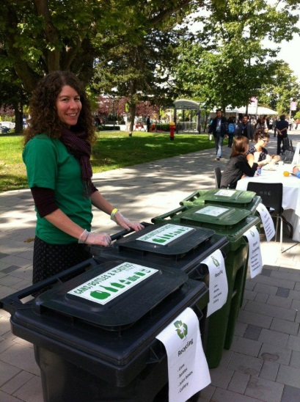
- Waste Free Volunteer Role and Info
Your main roles will be to:
- Stand next to a zero waste station
- Help people sort their waste properly by letting them know what goes in which bin
- Provide them with further information about recycling and waste reduction at UBC, should they ask. (See script.)

You will be provided with:
- a Sort It Out t-shirt
Lessons learned from previous events include:
- People are in a rush and want to quickly recycle and compost
- A lot of people just don’t know how to separate waste
Eliminating stand-alone garbage bins near the eating tent and having zero waste stations (a compost bin, recycling bin and garbage bins) around the tent, with a volunteer at each station, greatly enhanced waste diversion efforts.

- Key Messages
Here are some key messages and stats that you can share with staff at the event:

What
- Did you know most of UBC’s garbage can be recycled? Right now we recycle less than half.
- UBC is replacing individual garbage cans with multi-bin recycling stations.
- Our goal: Divert 60% of all materials from the landfill by 2016, and 80% by 2020
- UBC has its own closed-loop composting program. Our in-vessel composter, located in South Campus, turns organic waste collected across campus into soil within two weeks. The soil is then used for landscaping on campus.

Why
- Garbage rotting in landfills increases the risk of soil, water and air pollution; and creates the greenhouse gas methane.
- After January 2015 it will be prohibited to dispose of food scraps and compost in the garbage, and subject to a fine within Metro Vancouver.

2.0 What Goes Where?
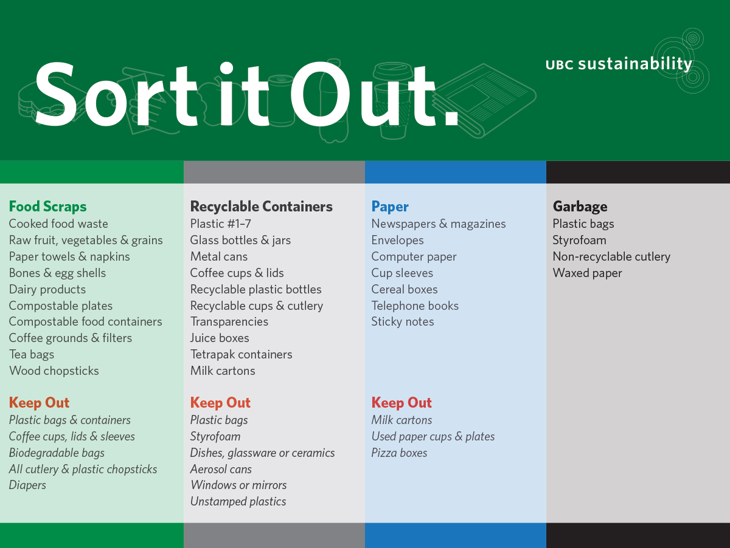
Most confusing items:
- Plastic
By keeping plastic out of the Food Scraps you can eliminate contamination and reduce what goes into our landfills. Place plastic containers marked #1-7 in the grey recyclable containers bin. Soft plastic (saran wrap, plastic bags) currently cannot be recycled at UBC.
- Paper Towels and Napkins
These can be composted, put them in the Food Scraps bin.
- Coffee Cups
All coffee cups can be recycled. Place empty cups and lids into the grey recyclable containers bin, and paper sleeves in the blue paper bin.

- Zero Waste Contact Information
Bud Fraser
Waste and Water Engineer at UBC
bud.fraser@ubc.ca

Ellen Hayes
Zero Waste Coordinator
zerowaste.coordinator@ubc.ca

Keiko Nariya
Zero Waste Events Coordinator
zerowaste.events@ubc.ca

